EX2-Create a simple cloud software application for Property Buying & Rental process (In Chennai city) using any Cloud Service Provider to demonstrate SaaS include the necessary fields such as Buy, Rent, commercial, Rental Agreement, Rental Agreement, Area, place, Range, property value etc.

PROCEDURE:

Step1: create an application name as happy home

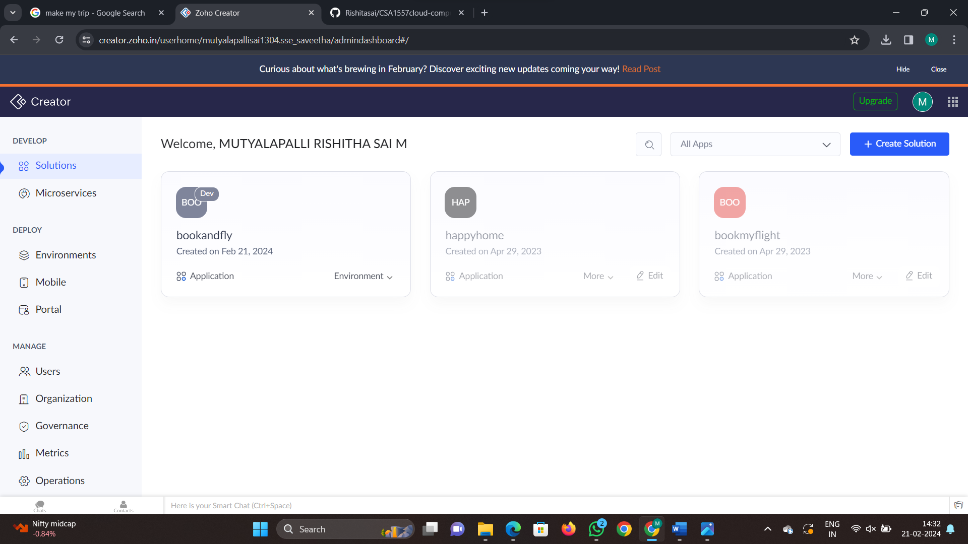

Step 2: select the form name as sales and fill required details in it and click done

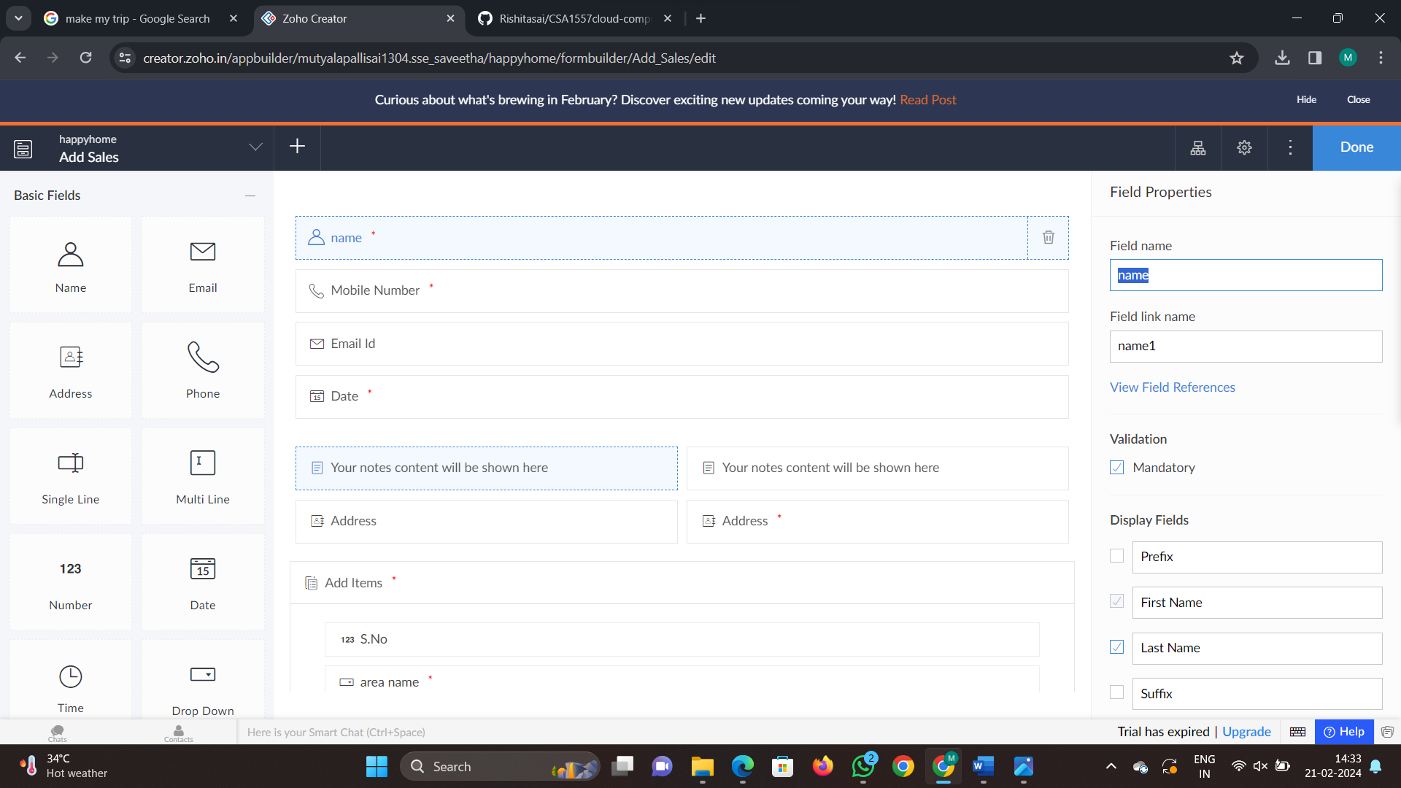

Step 3: Now report page for our form is automatically created and shown in the design page

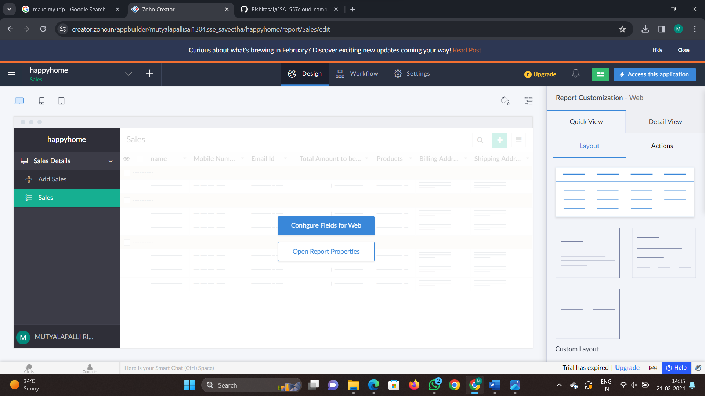

Step 4: Now create as many forms required and click on access development live

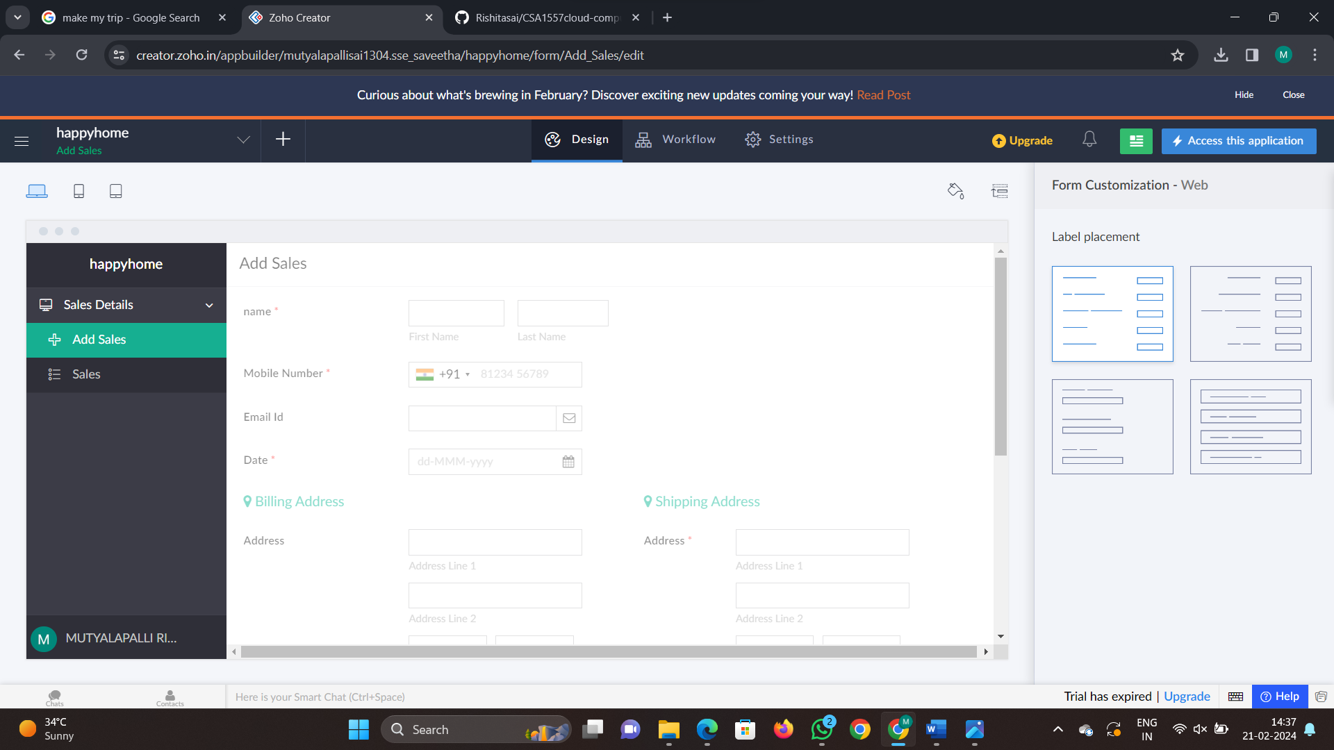

Step 5: now access the form with some dummy values and fill it

